Illustrate the Engineering Design Process for the given Application

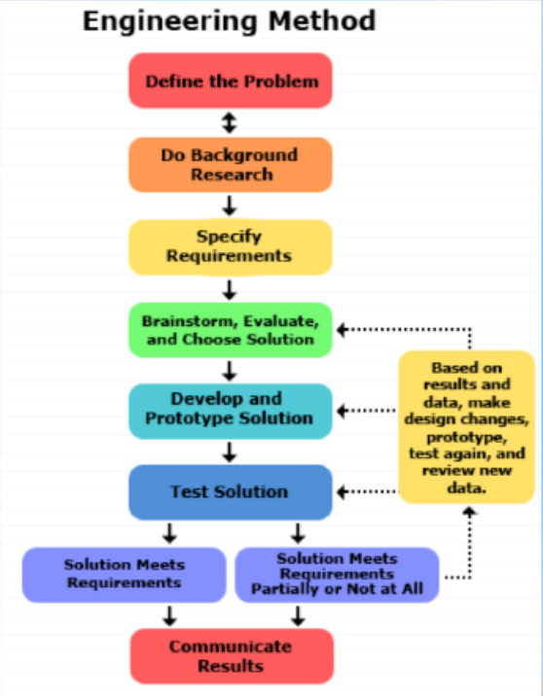

DEFINE A PROBLEM

Take a problem or product you want to work on.

Do background Research

Search all the information about the product. Find all the details of product and all the things related to product or problem related to product.

Specify requirements

Ask the clients for requirements or choose the requirements according to the environment of product. Or choose the conditions required for solving the problem most efficiently.

Brainstorm, Evaluate, And choose Solution

After getting the requirements, build the design for the prototype of the product keeping in check with environmental and market situations.

Build a prototype

After planning and having the blueprint of product. Build the product for testing in environment.

Test Solution And Redesign if necessary

Check the prototype if it meets the requirements of the client and if it satisfies the condition of environment and is effective in doing the job. If there are short comings then work on design and retest it.

Communicate Result

After all the testing the final prototype is the final result for the defined problem.

Engineering Design Process for Door Alarm using Arduino and Ultrasonic Sensor

DEFINE A PROBLEM

Integration of Arduino in door alarm and ultrasonic sensor

Do background Research

Ultrasonic Sensor

Ultrasonic sensor HC-SR04 is used here to detect the presences of any person at the door. The sensor module consists of ultrasonic transmitter, receiver and the control circuit. Ultrasonic Sensor consists of two circular eyes out of which one is used to transmit the ultrasonic wave and the other to receive it.

Specify requirements

Whenever anyone comes in the path/range of Ultrasonic Sensor, microcontroller detects the distance of object from the sensor and if the object is in the defined range, it sends the High signal to the buzzer and buzzer starts beeping.

Brainstorm, Evaluate, And choose Solution

In this project we have used NewPing.h Library for Ultrasonic sensor, developed by Tim Eckel. this Library provides many good features for Ultrasonic sensor and it becomes easy to Code for ultrasonic sensor using this library. We can use ultrasonic sensor’s functions easily using this library without writing too many lines of code; it’s like other libraries which are used to handle the complexity at lower level. Primarily Ultrasonic sensor is used to measure distance from any object, but here we can see that it can be used as Security alarm or Door alarm with Arduino.

Build a prototype

Build a prototype by using the following materials:-

* Breadboard
* Ultrasonic Sensor
* Buzzer
* Arduino Mega (any model)
* Jumper Wires
* USB cable for Arduino or 12v, 1A adapter.

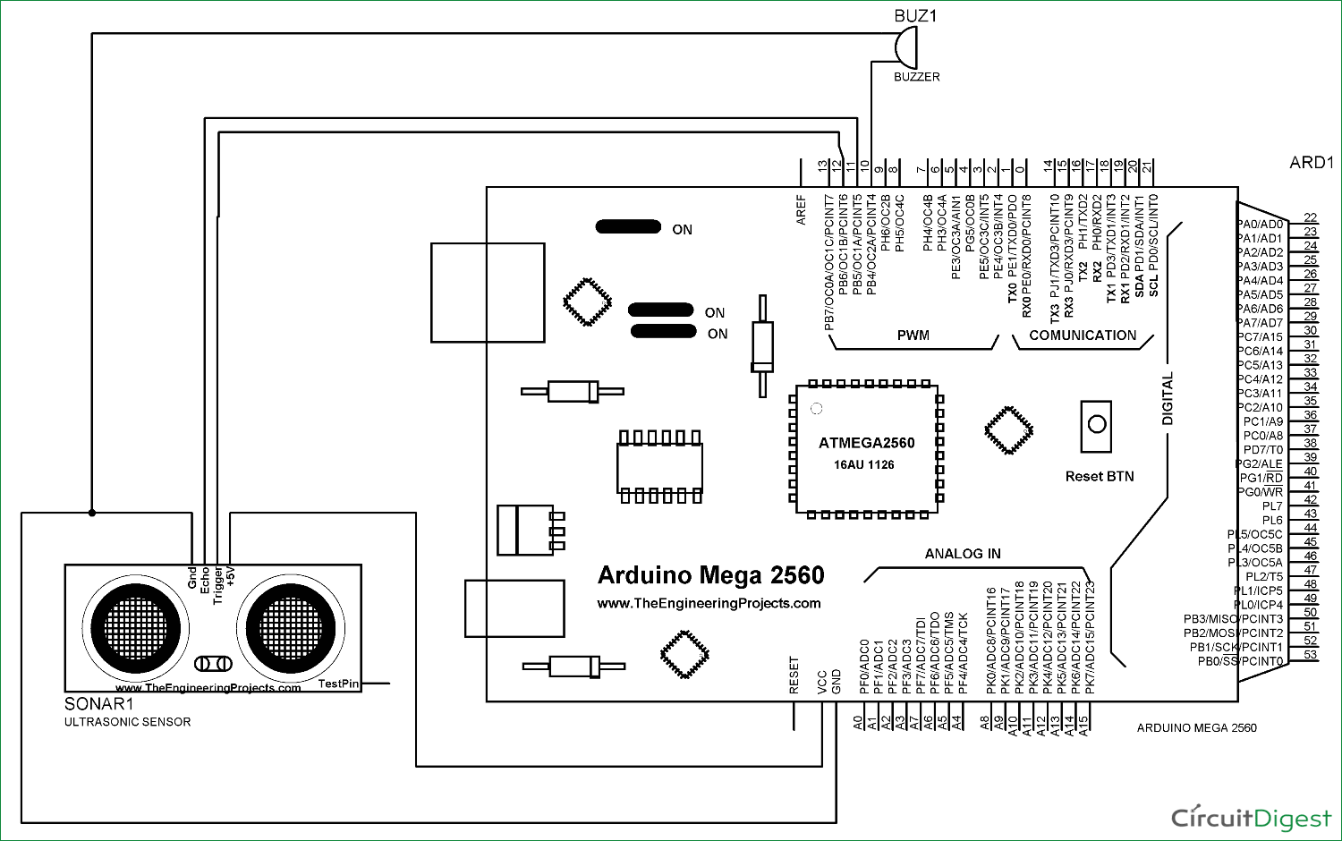 Test Solution and Redesign if necessary

Testing the prototype and code for communication between ultrasonic sensor and buzzer so it buzzer buzzes when sensor detects when there is a person detected by the sensor. Check the code and debug the code if there are any bugs and mistakes in code.

Communicate Result

Hence the given the prototype is the solution for the given problem